**Project 3B  
Morse Code Encoder/Decoder**

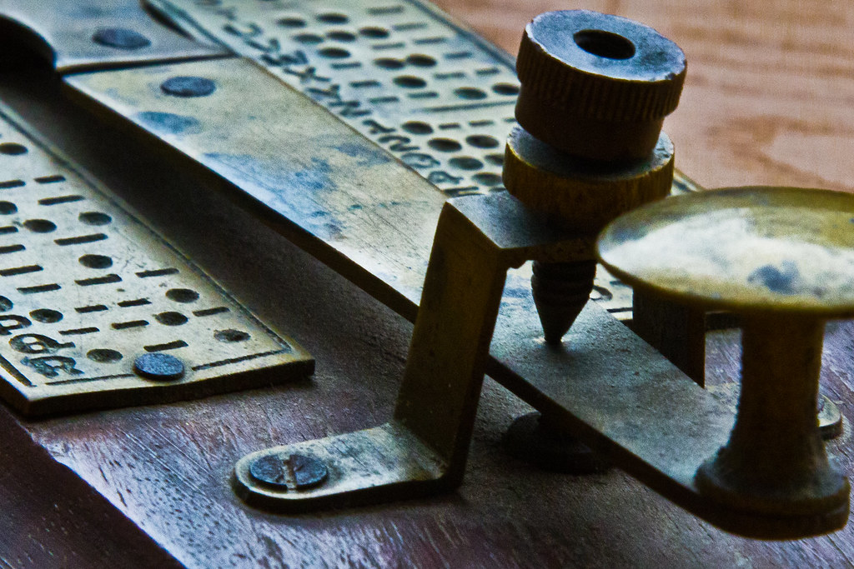

[This Photo](https://www.flickr.com/photos/63324741@N04/23562513626) by Unknown Author is licensed under [CC BY](https://creativecommons.org/licenses/by/3.0/)

12/11/2022

**Connor Clawson – Lubaba Masangu – Thanh Dat Nguyen**

# Introduction

This program decodes and encodes morse code from user input. Connor Clawson, Lubaba Masangu, and Thanh Dat Nguyen developed this program over the course of a month.

# Members Contribution

Thanh Dat wrote the decode and morse tree populator, Connor wrote the encode function and documentation, and Lubaba wrote the main function.

# UML Class Diagram

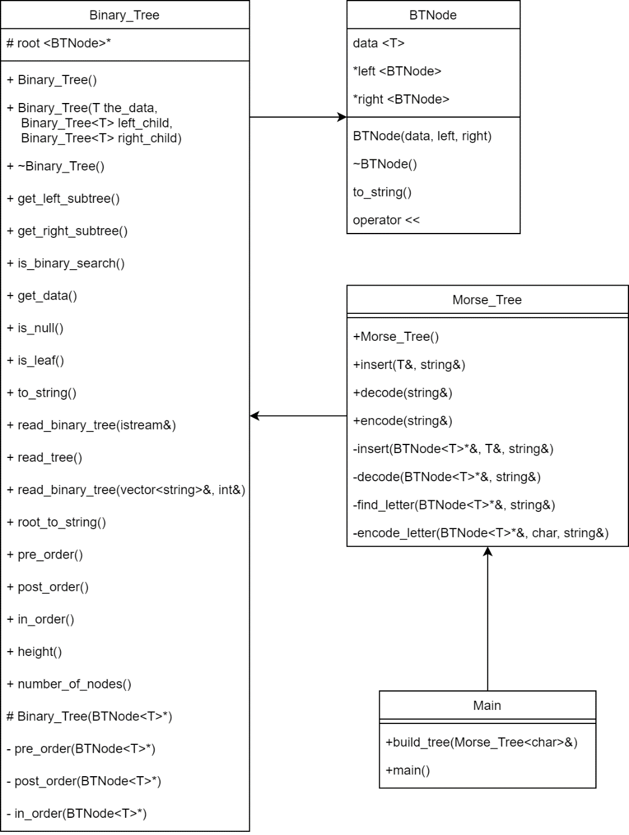

# Test Cases

Morse code to letters:

|  |  |  |
| --- | --- | --- |
| Morse Code | Expected result | Actual result |
| ••• ‒‒‒ ••• | SOS | SOS |
| •‒ ‒• ‒ | ANT | ANT |
| •‒‒• ‒‒‒ ‒ ••‒ ••• | POTUS | POTUS |

Letters to morse code:

|  |  |  |
| --- | --- | --- |
| Letters | Expected result | Actual result |
| SOS | ••• ‒‒‒ ••• | ••• ‒‒‒ ••• |
| ANT | •‒ ‒• ‒ | •‒ ‒• ‒ |
| POTUS | •‒‒• ‒‒‒ ‒ ••‒ ••• | •‒‒• ‒‒‒ ‒ ••‒ ••• |

# Improvements

Lubaba suggested expanding the tree to support numeric characters, Thanh Dat recommended switching from a binary tree node structure to a map to increase efficiency, and Connor wants to expand the encoder and decoder to support whole sentences.

# GitHub Repository

Repository package is available here:

<https://github.com/CClawsonSCC/SCC-Team-Project-3>